

**Benha University**

**Faculty of Science**

**Special Chemistry Department**

**Graduation Project**

**Synthesis Of Pyridine Derivatives**

**Presented by**

**Melad Aziz Fayek**

**Under Supervision of**

**Dr. Eman Ali Gad**

**(2024/2025)**

**Table of Contents**

1. Introduction.......................................................1

2. Historical Background of Pyridine..................................3

3. Solvent-free Synthesis of Substituted Pyrano-pyridopyrimidine under Different Conditions Using ZnO Nanoparticles...................4

# 4. Solvent-Free Synthesis of 2-Amino-4-aryl-6-substituted Pyridine-3,5-dicarbonitrile Derivatives………….……5

5. Synthesis of Pyridine Derivatives Using Magnetic Catalysts.........9

5.1 Basic Magnetic Catalysts.......................................9

5.2 Acidic Magnetic Catalysts......................................11

6. One-Pot Synthesis Catalyzed by NAP-MgO.............................13

7. Synthesis of DMAP Derivatives......................................13

8. Synthesis of a Novel Series of Imidazo Pyridine Derivatives........14

9. Oxidative Polycondensation of 3-Aminopyridine......................14

10. Synthesis of Pyridine-Quinoline Hybrids............................15

11. Synthesis of Pyridine Derivatives Using N-Propargylamines.........15

11.1 From N-Propargylamine and Ketones or Aldehydes...............15

11.2 Piperidine Synthesis.........................................18

11.3 Fused Pyridine Ring Systems..................................19

12. Conclusion........................................................20

13. References........................................................21

# **Introduction**

Pyridine is a basic heterocyclic organic compound with the chemical formula C₅H₅N. Structurally, it is analogous to benzene, a well-known fundamental aromatic molecule, with one of the CH groups replaced by a nitrogen atom. Like benzene, pyridine possesses a conjugated system of six π-electrons that are delocalized over the heterocyclic ring. The molecule is planar and adheres to Hückel’s rule for aromaticity, confirming its aromatic character.

Pyridine was first isolated in the mid-19th century as a byproduct of coal tar distillation. Since then, its importance has grown significantly due to its unique chemical properties, particularly its basicity and aromaticity, which make it a versatile scaffold in synthetic organic chemistry. Today, pyridine and its derivatives are essential in the design of drug molecules, ligands in coordination chemistry, and catalysts in various organic transformations.  
  
Pyridine derivatives constitute one of the most important classes of organic compounds due to their broad spectrum of biological activities and industrial applications. They are fundamental structural motifs found in a wide range of pharmaceuticals, including antibacterial, antiviral, and anticancer agents, as well as agrochemicals, dyes, and fuel additives.  
  
However, conventional methods for the synthesis of pyridine derivatives often involve the extensive use of hazardous organic solvents, raising significant environmental and health concerns. In light of these challenges, the pursuit of sustainable and eco-friendly synthetic strategies has become a crucial focus, aligning with the principles of green chemistry.

Green chemistry emphasizes the design of chemical products and processes that reduce or eliminate the use and generation of hazardous substances. Its key principles—such as atom economy, the use of safer solvents and auxiliaries, improved energy efficiency, and the utilization of renewable feedstocks—play a crucial role in modern organic synthesis. In the context of synthesizing pyridine derivatives, applying these green principles facilitates the development of cleaner, safer, and more sustainable synthetic methodologies. This not only enhances the environmental compatibility of the reactions but also aligns with the growing demand for efficient and eco-conscious production of biologically active pyridine-based compounds.

Among the various green methodologies, solvent-free synthesis techniques, particularly those employing microwave irradiation, have emerged as highly efficient and environmentally benign alternatives. These approaches offer several advantages, including shorter reaction times, higher product yields, minimized waste production, and improved energy efficiency.

Multi-component reactions (MCRs) have proven to be one of the most powerful and versatile synthetic strategies for the preparation of complex organic molecules. MCRs offer the advantage of assembling diverse functional groups into a single product in a single step, reducing the need for multiple synthetic routes and minimizing waste. When conducted under solvent-free conditions, these reactions become even more attractive due to the enhanced efficiency and environmental benefits they offer.

This study aims to explore new, sustainable methods for synthesizing a variety of pyridine-based compounds, including aminopyridine derivatives, pyrano-pyridopyrimidines, and other biologically relevant structures. These methods are designed to provide high yields, short reaction times, and minimal environmental impact, contributing to the advancement of green synthetic chemistry.

# **Historical Background of Pyridine**

The name pyridine is derived from the Greek language, combining the words “pyr”, meaning fire, and “idine”, a suffix commonly used for aromatic bases. The first pyridine derivative, picoline (Compound 1), was isolated in 1846 by Anderson. However, its chemical structure remained unclear for some time.

In 1869, Wilhelm Körner, and independently in 1871, James Dewar, proposed that the structure of pyridine could be analogous to quinoline and naphthalene. It was eventually concluded that pyridine could be derived from benzene by replacing one CH group with a nitrogen atom, preserving the aromaticity of the ring.

In 1876, William Ramsay successfully synthesized pyridine by reacting acetylene with hydrogen cyanide in a red-hot iron-tube furnace, marking one of the earliest synthetic approaches to this heterocyclic compound. This foundational work laid the basis for further exploration into pyridine chemistry and its derivatives.

**1-Multi-component Reactions, Solvent-free Synthesis of Substituted Pyrano-pyridopyrimidine under Different Conditions Using ZnO Nanoparticles**

Multi-component reactions under solvent-free conditions using ZnO nanoparticles as a catalyst presented itself as a remarkable technique toward environmentally clean synthesis of organic compounds [26](https://onlinelibrary.wiley.com/doi/full/10.1002/jhet.3556#jhet3556-bib-0026), [27](https://onlinelibrary.wiley.com/doi/full/10.1002/jhet.3556#jhet3556-bib-0027). Herein, ZnO nanoparticles [28](https://onlinelibrary.wiley.com/doi/full/10.1002/jhet.3556#jhet3556-bib-0028) were used as a catalyst during the condensation reactions of aromatic aldehydes, 3H-pyrido[1,2-a]pyrimidine-2,4-dione 1 and malononitrile in order to afford new moieties, namely, 2-amino-4-(4-substitutedphenyl)-5-oxo-4H,5H-pyrano[2,3-d]pyrido[1,2-a] pyrimidine-3-carbonitrile derivatives 2–12 (Scheme [1](https://onlinelibrary.wiley.com/doi/full/10.1002/jhet.3556#jhet3556-fig-0002)).

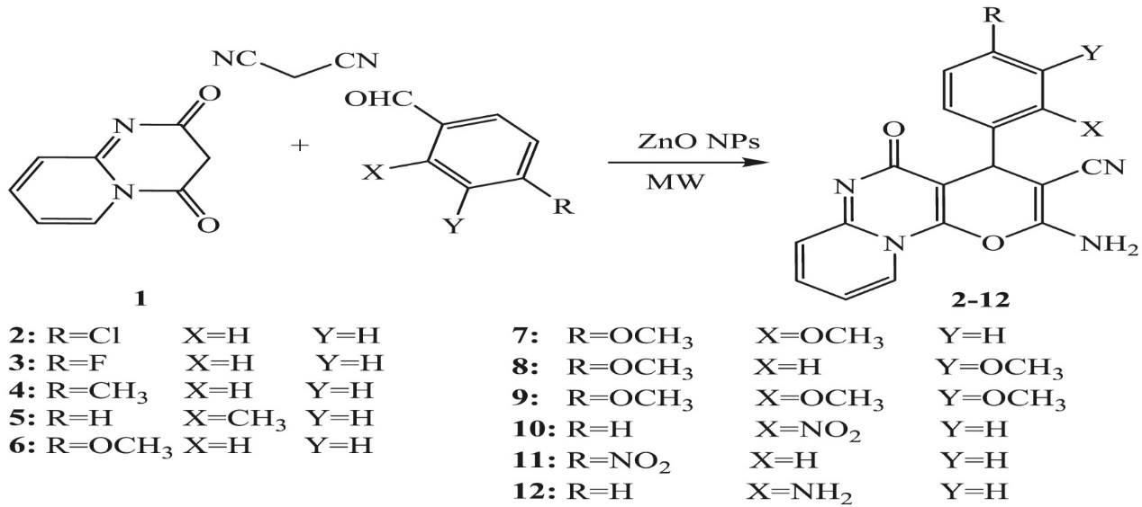

**Scheme 1**

The reaction mechanism

ZnO nanoparticles behave as Lewis acid and coordinate to the carbonyl groups of 3H-pyrido[1,2-a]pyrimidine-2,4-dione and aldehydes that makes them susceptible to nucleophilic attack of other reactants (Scheme [2](https://onlinelibrary.wiley.com/doi/full/10.1002/jhet.3556#jhet3556-fig-0003)).

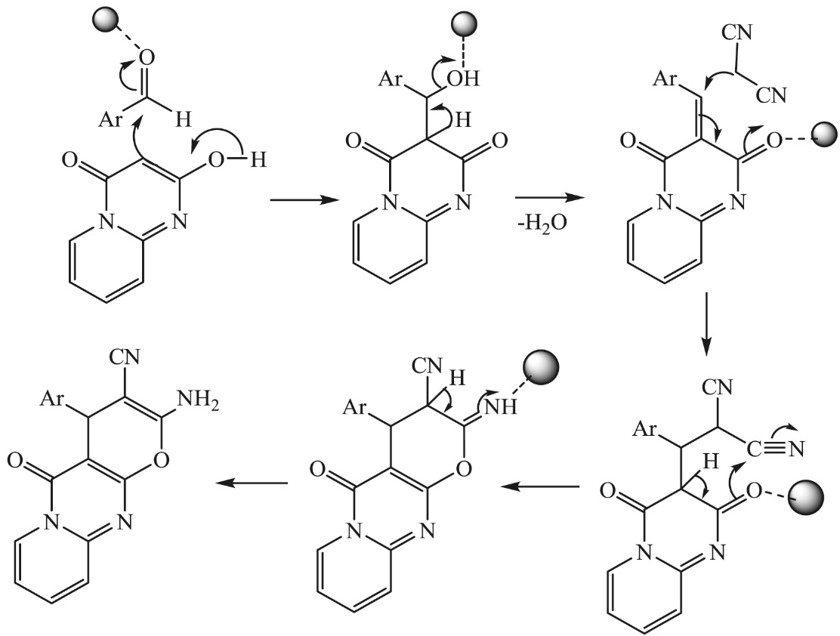

**Scheme 2**

# **2-Multicomponent Reactions, Solvent-Free Synthesis of 2-Amino-4-aryl-6-substituted Pyridine-3,5-dicarbonitrile Derivatives.**

According to the literature [22], 2-amino-4-aryl-6-substituted pyridine-3,5-dicarbonitrile derivatives were synthesized by a multistep pathway using ZnCl₂ as the catalyst at 75°C, achieving an 81% yield. However, these reactions typically involve the use of solvents and multiple reaction steps.

one-pot multicomponent reactions (MCRs) were investigated for the preparation of aminopyridine derivatives (1–20) using different Lewis acid catalysts such as ZnCl₂, AlCl₃, and FeCl₃ with a molar ratio of 1:2:3 (aromatic aldehydes: malononitrile: primary amines), which led to moderate yields.

The first trial was conducted using one equivalent of aromatic aldehydes, two equivalents of malononitrile, and one equivalent of primary amines in the presence of ZnO nanoparticles, CAN, NaOEt, and/or H₃PO₄ as catalysts in refluxing ethanol for 12 hours. Despite varying the molar ratios of amines, no products were observed. However, in a subsequent neat reaction, the components were combined without the use of solvents, achieving a significant improvement in yield. This result demonstrated the potential of solvent-free conditions to enhance the efficiency of the reaction and reduce environmental impact. The reaction setup and key conditions for these experiments are summarized in Scheme 3, which visually illustrates the multicomponent reaction pathway and highlights the differences in reaction conditions.

**Scheme3**

The second trial was carried out using ethanolic solutions of aromatic aldehydes, malononitrile, and primary amines in the presence of Lewis acid catalysts such as AlCl₃, ZnCl₂, and FeCl₃. The reaction mixtures were refluxed for 6 hours using various molar ratios of aromatic aldehydes: malononitrile: primary amines, and it was found that a 1:2:3 ratio provided the best results, affording the desired products in moderate yields.

To improve the efficiency and sustainability of the process, a subsequent experiment was performed under solvent- and catalyst-free (neat) conditions, where the three components—aromatic aldehydes (1 eq), malononitrile (2 eq), and primary amines (1 eq)—were fused together directly. This approach led to the formation of solid products corresponding to various 2-amino-4-aryl-6-substituted pyridine-3,5-dicarbonitrile derivatives (compounds 1–20) with significantly higher yields. The synthetic route and conditions employed for this optimized reaction are illustrated in Scheme 4.

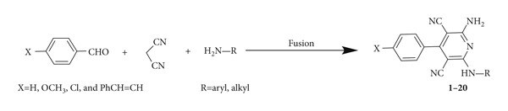

**Scheme 4**

In conclusion, a solvent-free, one-pot multicomponent reaction without using any catalysts has been developed for the first time. With this method, a wide range of novel 2-amino-4-aryl-6-substituted pyridine-3,5-dicarbonitrile derivatives were synthesized in high yields with a broad substrate of functional groups. Those derivatives are depicted in

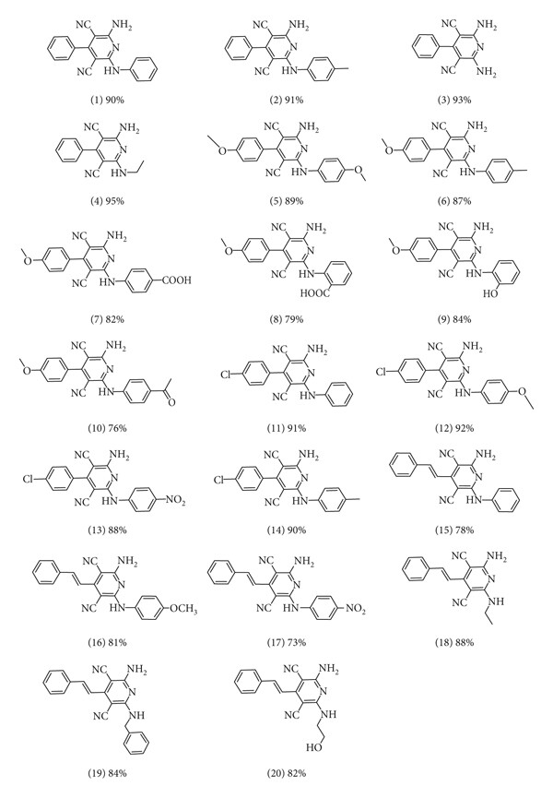

**Scheme 5**

# **3- The synthesis of pyridine derivatives by diverse magnetic catalysts**

### **3.1. Basic magnetic catalyst**

* **Synthesis of tetrahydrodipyrazolopyridine 11**

Fe3O4@KCC-1-nPr-NH2 **6** was employed in the tetra-component reaction of ethyl acetoacetate **7**, hydrazine hydrate **8**, ammonium acetate **10**, and various aromatic aldehydes **9** in ethanol under reflux condition for the synthesis of tetrahydrodipyrazolo pyridine **11** in excellent yields, short reaction times. According to obtained results, different substituents including electron-donating or electron-withdrawing groups on the aromatic ring, did not affect the product yields. All products were obtained in high purity and excellent yields. Also, the anticancer activity of tetrahydrodipyrazolo pyridine derivatives **11** was studied that some of these compounds showed good cytotoxic activity toward types of cancer cell ([Scheme 6](https://pubs.rsc.org/en/content/articlehtml/2021/ra/d1ra02418c#imgsch2)).

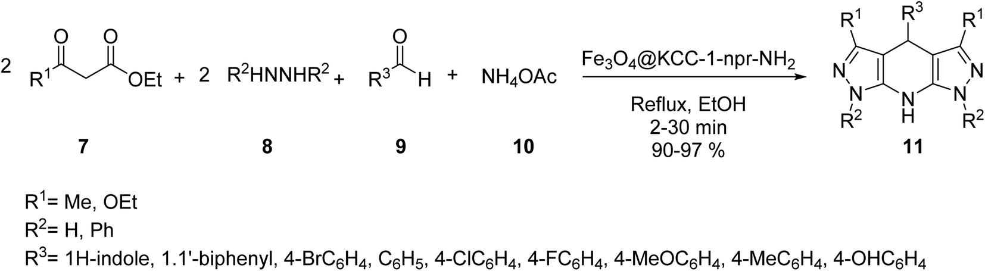

[**Scheme 6**](https://pubs.rsc.org/en/content/articlehtml/2021/ra/d1ra02418c#imgsch2)

* **Synthesis of 2-amino-4,6-diphenylnicotinonitriles 23.**

The nano-magnetic catalyst **21** was examined in the multicomponent reaction of benzaldehydes **9**, acetophenone derivatives **22**, malononitrile **16,** and ammonium acetate **10** under the solvent-free condition in 80 °C for the preparation of 2-amino-4,6-diphenylnicotinonitriles **23** ([Scheme 7](https://pubs.rsc.org/en/content/articlehtml/2021/ra/d1ra02418c#imgsch6)).

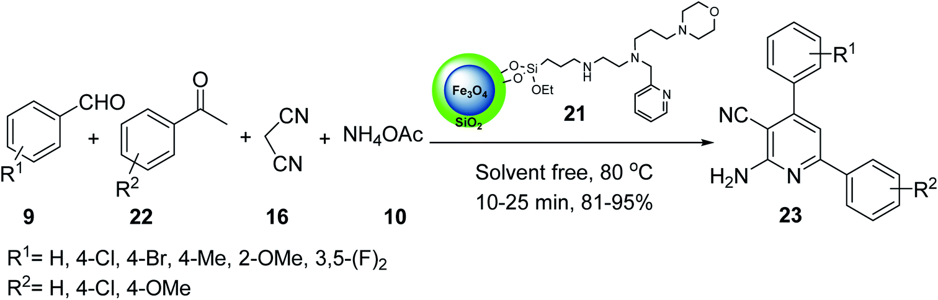

[**Scheme 7**](https://pubs.rsc.org/en/content/articlehtml/2021/ra/d1ra02418c#imgsch6)

* **Synthesis of 2-amino-3-cyanopyridines 23.**

Fe3O4–Si–(CH2)3–N[double bond, length as m-dash]CH–Ph–OMe MNPs **29** was used in the synthesis of 2-amino-3-cyanopyridines **23** via the multicomponent reaction of various aromatic aldehydes **9**, 2-acetylnaphthalene **31,** or deoxybenzoin **31**, malononitrile **16**, and ammonium acetate **10** under solvent-free conditions at 120 °C for 40–70 min in good to high yield in short times ([Scheme 8](https://pubs.rsc.org/en/content/articlehtml/2021/ra/d1ra02418c#imgsch8)).

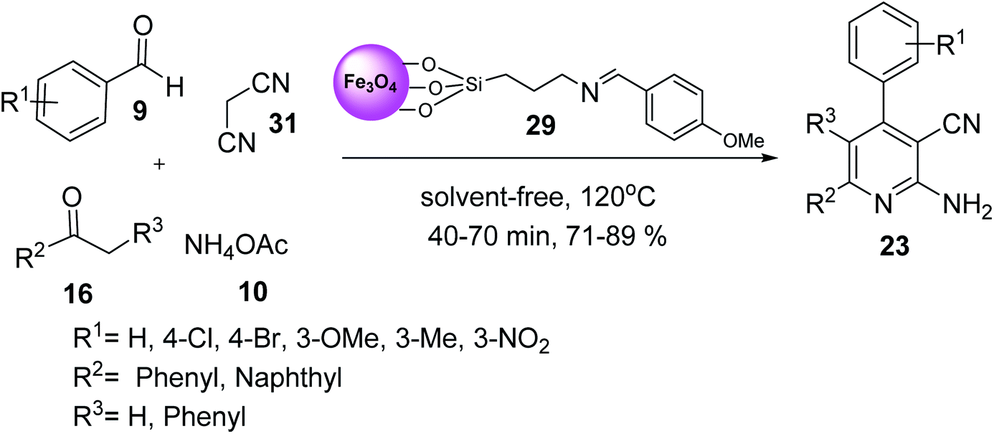

[**Scheme 8**](https://pubs.rsc.org/en/content/articlehtml/2021/ra/d1ra02418c#imgsch8)

### **3.2. Acidic magnetic catalysts**

* **Synthesis of 2-amino-4-aryl-6-(phenylsulfanyl)pyridine-3,5-dicarbonitrile derivatives 35**

Fe3O­4@macrocyclic Schiff base ligand **34** was employed in the synthesis of 2-amino-4-aryl-6-(phenylsulfanyl)pyridine-3,5-dicarbonitrile derivatives **35** via three-component reaction of aldehyde derivatives **9**, malononitrile **16**, thiophenol **36** under solvent-free conditions ([Scheme 9](https://pubs.rsc.org/en/content/articlehtml/2021/ra/d1ra02418c#imgsch10)). The catalytic activity of Fe3O4@CoII (macrocyclic Schiff base ligand) **34** was separately compared to that of Fe3O4, macrocyclic Schiff base ligand, Fe3O4@macrocyclic Schiff base ligand **33**. It was demonstrated that Fe3O4@CoII **34** showed the best results.

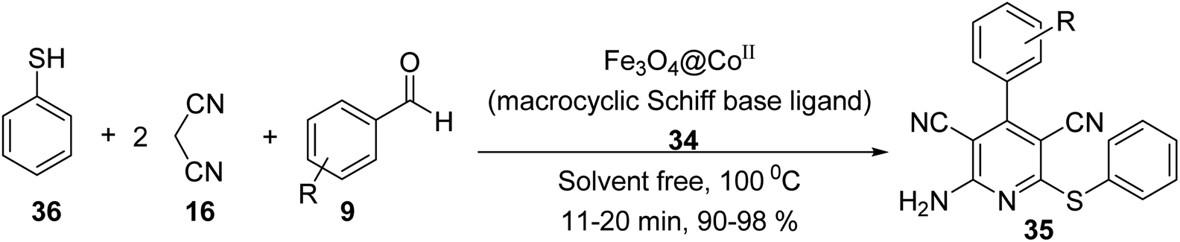

[**Scheme 9**](https://pubs.rsc.org/en/content/articlehtml/2021/ra/d1ra02418c#imgsch10)

* **Synthesis of pyrazolo[3,4-*b*] pyridines 40**

4-Aroyl-3-methyl-1,6-diaryl-1H-pyrazolo[3,4-b] pyridine-5-carbonitrile derivatives **40** were synthesized via one-pot, the four-component reaction of 1-aryl-3-methyl-1H-pyrazol-5-(4H) one **39**, 3-aryl-3-oxopropanenitriles **37**, arylglyoxals **38,** and ammonium acetate **10** in the presence of metal oxide silica based-metal bifunctional LDH (layered double hydroxide) as a magnetic nano-catalyst in EtOH/H2O (1[thin space (1/6-em)]:[thin space (1/6-em)]1) under the reflux conditions ([Scheme10](https://pubs.rsc.org/en/content/articlehtml/2021/ra/d1ra02418c#imgsch11)). In addition, pyrazolo[3,4-b] pyridines **40** have biological and pharmacological activity.

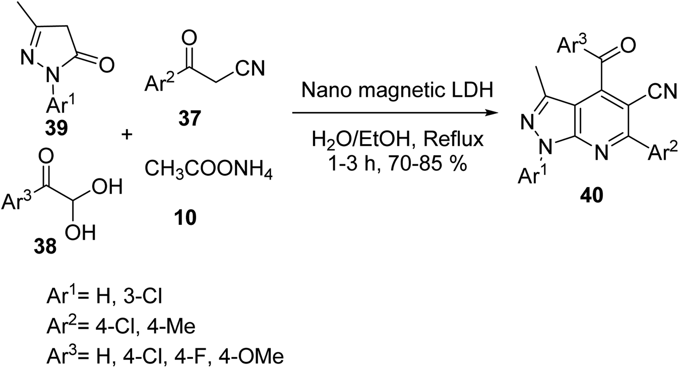

**Scheme 10**

* **Synthesis of 2-amino-4,6-diarylnicotinonitrile derivatives 23.**

CoFe2O4@Silica MNPs **44** was used in the multicomponent reaction of aldehydes **9**, acetophenone **22**, malononitrile **16**, and ammonium acetate **10** in solvent-free conditions under MW irradiation to provide 2-amino-4,6-diarylnicotinonitrile derivatives  **23**  in good yields ([Scheme 11](https://pubs.rsc.org/en/content/articlehtml/2021/ra/d1ra02418c#imgsch13)).

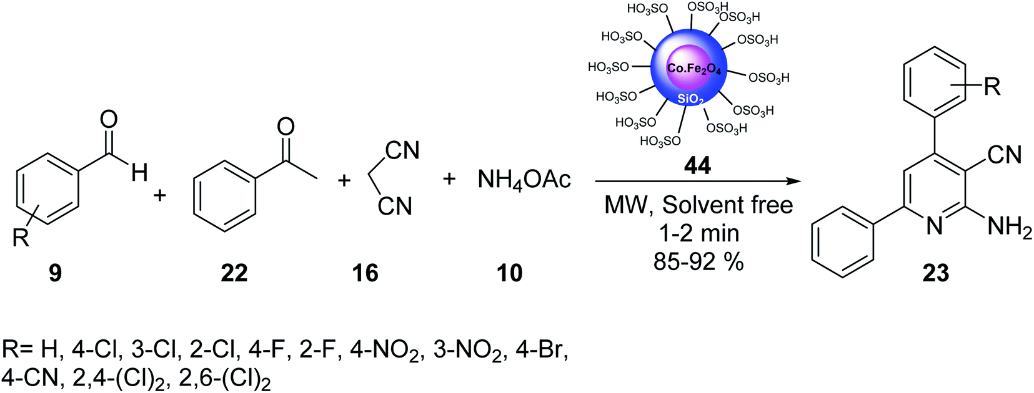

[**Scheme 11**](https://pubs.rsc.org/en/content/articlehtml/2021/ra/d1ra02418c#imgsch13)

## **4-On-pot Synthesis of Pyridines Catalyzed by NAP-MgO [3]**

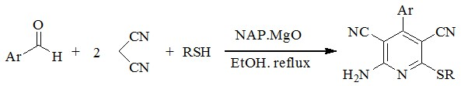

**Scheme 12**

**5-Synthesis of DMAP [4-(N,N-dimethylamino) Pyridine] Derivative [4]**

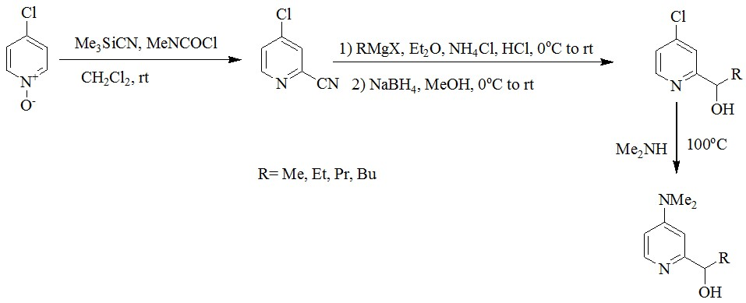

**Scheme 13**

**6-Synthesis of a novel Series of Imidazo Pyridine Derivatives [5]**

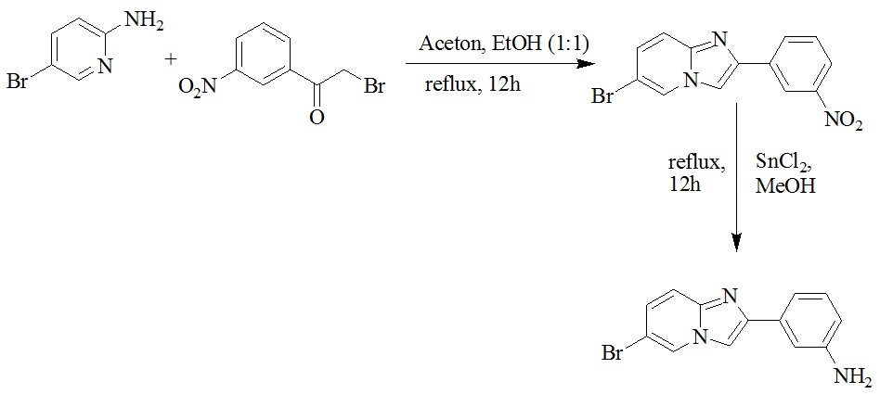

**Scheme 14**

**7-Oxidative Polycondensation Reaction of 3-Aminopyridine [6]**

N

CH

3

COOH/KOH

aq

NaOCl

N

H

N

*

**Scheme 15**

**8-Synthesis of Pyridine-Quinoline Hybrid [7]**

N

Br

O

-

K

+

N

+

K

-

O

Cl

+

DMSO, 150

o

C

h

8

N

O

O

N

**Scheme 16**

## **-9Synthesis of Pyridine Derivatives Using N-Propargylamines**

### **9.1. From *N*-propargylamine and ketones or aldehydes**

synthesis of pyridine derivatives by treatment of carbonyl compounds with N-propargylamine in the presence of NaAuCl4·2H2O, a variety of functionalized pyridines 12 were synthesized via the Au-catalyzed amination/annulation/aromatization reaction of ketones or aldehydes bearing α-hydrogens 10 and N-propargylamine 11 in refluxing ethanol (Scheme 17). The mechanism proposed for this transformation involves the formation of the imino intermediate A by Au-catalyzed condensation reaction of the ketone 10 with N-propargylamine 11. This intermediate undergoes imine–enamine isomerization to form intermediate B. The formation of organometallic intermediate C occurs next, followed by its protonolysis to give the dehydropyridine D that transforms to the final product by a dehydrogenation process (scheme18.).

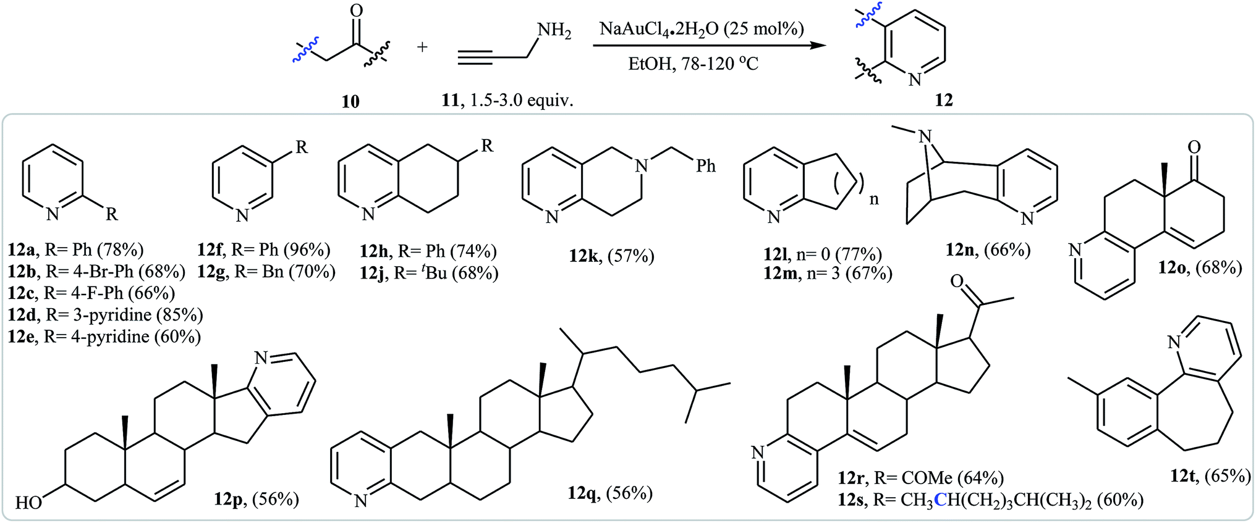

**Scheme 17**

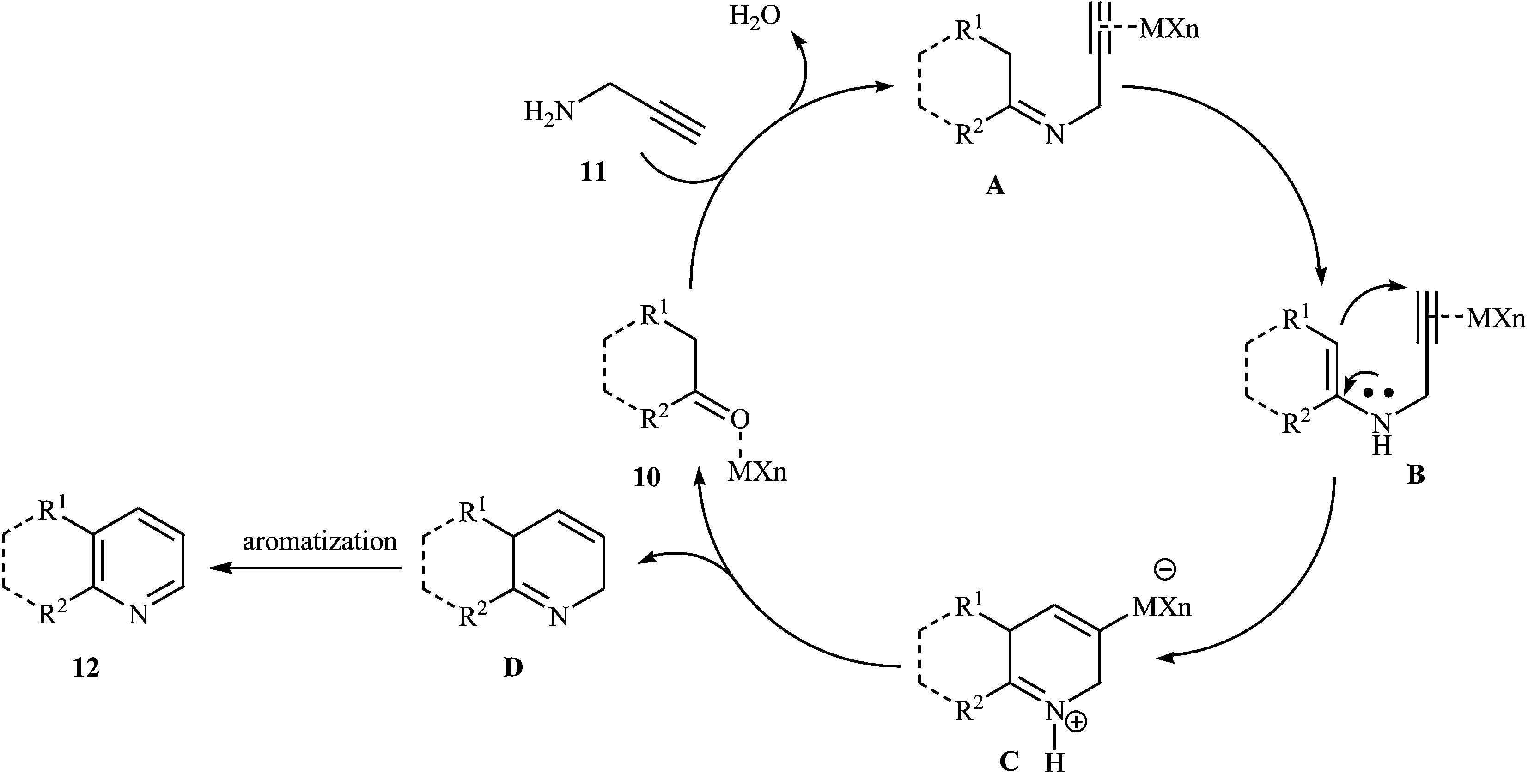

**Scheme 18**

In a closely related investigation, Yan, Li, and Rao also described that the reaction of steroidal carbonyl compounds **13** with N-propargylamine **11** in presence of Cu(NO3)2·3H2O as catalyst, produced corresponding 3,4-fused pyridine compounds **14** in moderate yields ([Scheme 19](https://pubs.rsc.org/en/content/articlehtml/2016/ra/c6ra08720e#imgsch6)).

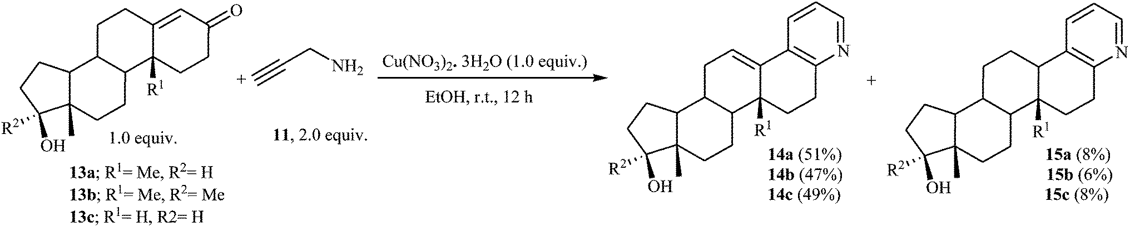

**Scheme 19**

In 2015, H. Zhai and co-workers reported one example of pyridine preparation from direct condensation of N-propargylamine **11** and cinnamaldehyde **16** in the presence of DBU as base in PhCl. As shown in [Scheme 20](https://pubs.rsc.org/en/content/articlehtml/2016/ra/c6ra08720e#imgsch7) the target pyridine **17** was obtained in yield of 70% via a condensation/isomerization/6-π-3-azatriene electrocyclization/1,3-H shift sequential process ([Scheme 20](https://pubs.rsc.org/en/content/articlehtml/2016/ra/c6ra08720e#imgsch7)).

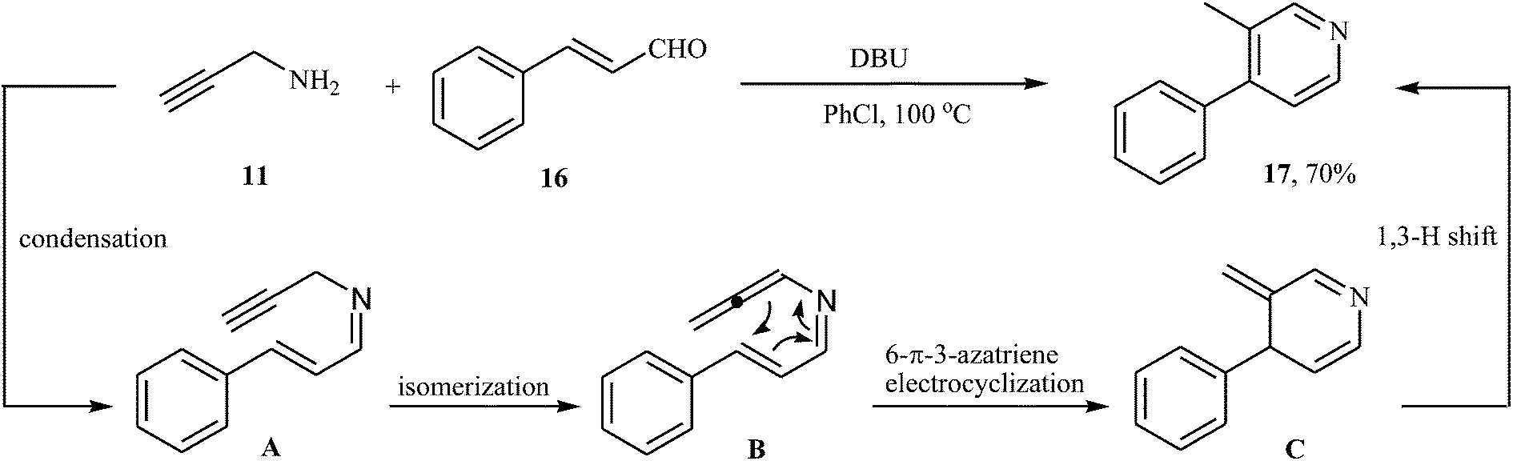

**Scheme 20**

## **9.2.** **Piperidines**

The use of N-propargylamines as starting substrates in the synthesis of piperidines has been scarcely studied. In 2009, Leblod, Leduc, and Kerr by studying the chemistry and application of the benzyl-protected propargyl amines 43, discovered that they reacted with 1,1-cyclopropane diesters 44 in the presence of Zn(NTf2)2 as catalyst to produce highly substituted piperidines 45 in good to excellent yields (Scheme 21a). According to the proposed mechanism, the key steps of the reaction involves a cyclopropane ring-opening and a Conia-ene cyclization (Scheme 21b).

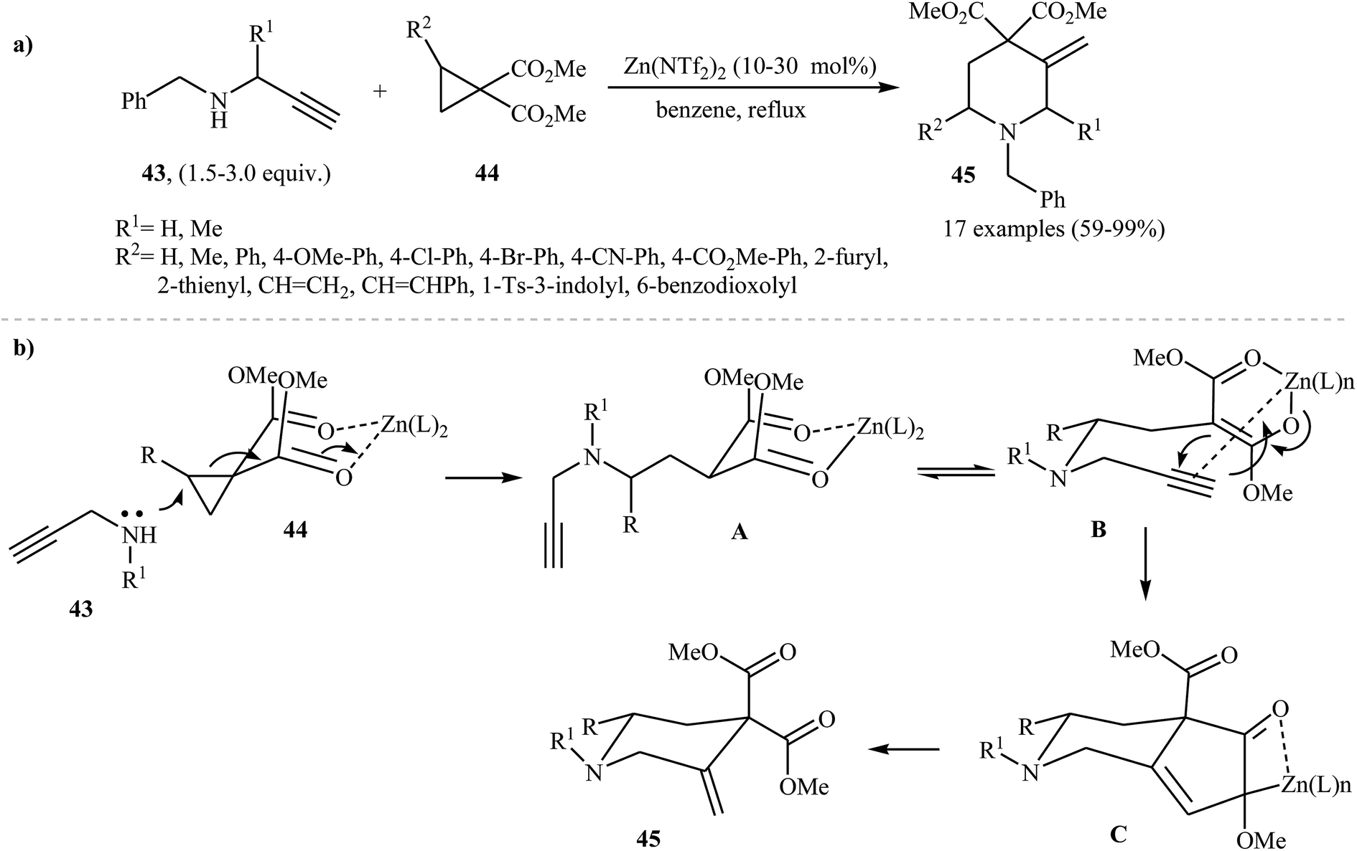

**Scheme 2***1*

## **9.3 Fused pyridine ring**

N-propargylic β-enaminones are interesting starting materials to access substituted pyridines. Based on duel role of these compounds, Karunakar and co-workers were able to demonstrate that a series of pyridine systems 48 could be obtained from the reaction of N-propargylic β-enaminones 46 with acetylenedicarboxylates 47 under catalyst and base-free conditions in acetonitrile (Scheme 22a). The results showed that N-propargylamines with electron-donating groups gave higher yields than those with electron-withdrawing groups. For acetylenedicarboxylates 47, the decreasing order of reactivity is diethyl but-2-ynedioate > di-tert-butyl but-2-ynedioate > dimethyl but-2-ynedioate. According to the proposed mechanism, the reaction proceeds in four consecutive steps: (i) formation of an iminic intermediate A through nucleophilic addition of 46 to the electrophiles 47, (ii) tautomerization of A to form intermediate B, (iii) intramolecular cyclization of intermediate B to produce cyclic intermediate C and (iv) cyclopropanation of C to the expected product 48 (Scheme 22b).

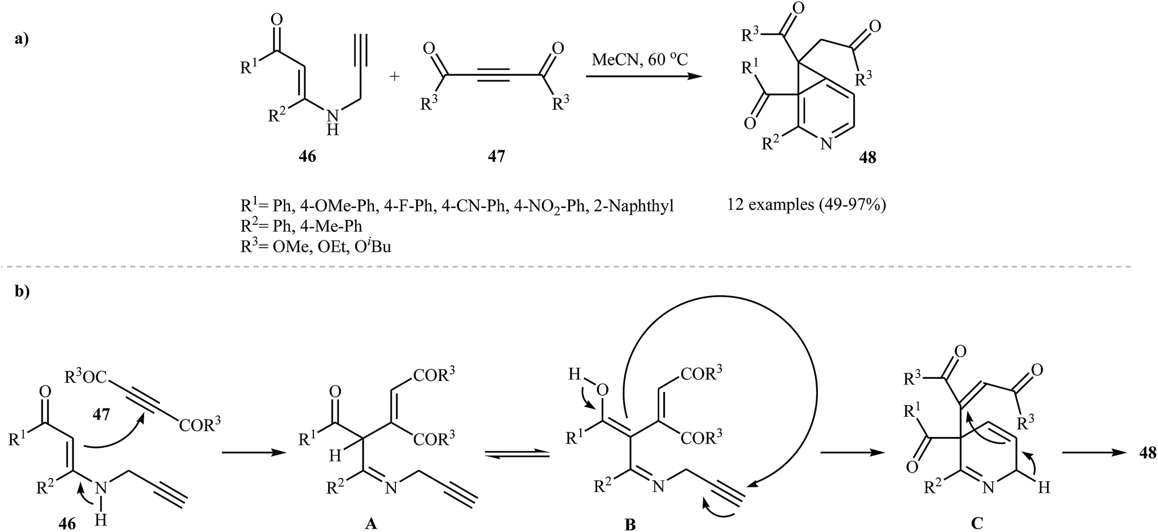

**Scheme 2***2*

**Conclusion**

The synthesis of pyridine derivatives represents a cornerstone in organic chemistry due to their significant applications in pharmaceuticals, agrochemicals, and advanced materials. This project provided a comprehensive study of various synthetic approaches for pyridine-based compounds, including traditional methods, multicomponent reactions, metal and magnetic catalysis, as well as solvent-free techniques.

The findings revealed that the diversity of synthetic strategies enables the production of a wide range of biologically and chemically valuable pyridine derivatives, with enhanced efficiency, product quality, and environmental compatibility. The use of modern catalysts and optimized experimental conditions facilitated rapid, high-yielding transformations.

**Reference**

1. Rai, A., Rani, R., & Singh, J. (2021). One-pot solvent-free synthesis of substituted pyridines using nano-Al₂O₃. *J. Heterocyclic Chem.*, 58(9), 1733–1741.

2. Singh, J., et al. (2020). Solvent-free synthesis of poly-substituted imidazoles using nanocatalysts. *J. Mol. Catal. A*, 498, 111278.

3. Kumar, V., & Singh, J. (2019). Green chemistry approaches to heterocycle synthesis. *Green Chem. Lett. Rev.*, 12(3), 250–265.

4. Iqbal, J., Abbasi, M. A., Khan, A., et al. (2018). Recent trends in pyridine derivatives. *J. Chem.*, 2018, 7958739.

5. Asiri, A. M., & Khan, S. A. (2016). Recent advances in pyridine scaffolds. *Arabian J. Chem.*, 9(2), S1436–S1444.

6. Siddiqui, N., et al. (2015). Medicinal importance of dihydropyridines. *Eur. J. Med. Chem.*, 89, 207–251.

7. Farooq, M. U., et al. (2021). Recent advances in synthesis and biological applications of pyridines. *RSC Adv.*, 11, 19558–19588.

8. Zhou, W., et al. (2020). Multicomponent reactions in pyridine chemistry. *Org. Chem. Front.*, 7(2), 143–157.

9. Ali, I., & Saleem, K. (2019). Applications of pyridine-based drugs. *Bioorg. Chem.*, 87, 323–335.

10. Bhatia, B. L., & Sharma, S. (2016). Medicinal importance of pyridine derivatives. *Unpublished review*, ResearchGate.

11. Prajapati, D., & Sandhu, J. S. (2010). Synthesis of pyridines: Classical and modern methods. *Chem. Rev.*, 110(3), 1065–1103.

12. Brown, D. J. (2009). The pyridine ring in drug design. *Pharm. Chem. J.*, 43(3), 123–136.

13. Shaterian, H. R., & Yarahmadi, H. (2016). Solvent-free synthesis catalyzed by Al₂O₃-supported Lewis acids. *RSC Adv.*, 6, 67305–67312.

14. Zolfigol, M. A., et al. (2015). Efficient green synthesis of pyridines under solvent-free conditions. *Green Process. Synth.*, 4(1), 15–22.

15. Saidi, M. R., & Mohammadpoor-Baltork, I. (2014). Catalysis in solvent-free heterocyclic synthesis. *Curr. Org. Chem.*, 18(6), 732–745.